7052 Santa Teresa Blvd
San Jose, CA. 95139

For Immediate Release

Salmon Croquettes

Novel by Glodean Champion explores gender non-conformity and homophobia against a backdrop of injustice and police brutality.

In 1965, “The Circle” in Watts, Los Angeles, was filled with its own particular joys and troubles. This vibrant neighborhood comes alive in Salmon Croquettes, a heartwarming, humorous, and sometimes heartbreaking, historical fiction that brilliantly exposes the strength, resilience, and interconnectedness of the Black community.
Salmon Croquettes
by Glodean Champion

Publication Date
March 2021

ISBN
9780578767550

320 pages
$27.99, hardcover
$17.99, paper
$14.99, ebook

Category
YA Fiction

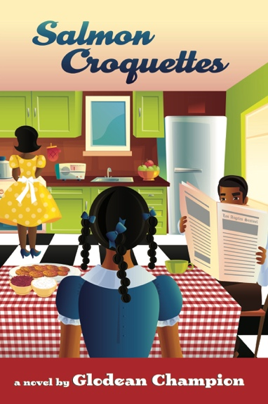
Zayla Lucille McKinney grapples with the confusion of feeling like a boy trapped in a girl's body. Is she what the other girls call her, a "bulldagger"? And what does that even mean? In the midst of her transformation from 12-year-old tomboy to young woman, the community she loves explodes in a racial uprising. The Watts Riots teach Zayla the fragility of life and the importance of friendship. As the embers die down and the smoke clears, Zayla also learns something else, a family secret. Salmon Croquettes is a sensitive exploration of Zayla's transition from childhood incomprehension – why do adults expect children to magically understand what is not acceptable? – to an acceptance of who she is and the truth of who her parents really are.

“This accomplished novel will keep you turning the page and rooting for this young, full-of-spunk protagonist. Glodean Champion has written a novel that will capture the hearts of many, including young African American girls who identify outside of the traditional, pink-frilly girl norm. A must read.”
~ Opal Palmer Adisa, author of Love’s Promise

Glodean Champion is a Los Angeles-born storyteller, coach, and educator now living in Monterey, CA. With a BA in English Literature from Mills College in Oakland and an MFA in Writing from California College of the Arts in San Francisco Glodean strives to explore sexuality, gender, racism, and the beauty and strength of the Black spirit in her writing. She is a Voices of Our Nation Arts (VONA) Foundation and Hurston-Wright Foundation alum. Salmon Croquettes is her debut novel.
CONTACT

Lori Johnson
Publishing Assistant
(831) 540-4607

publisher@
blackmusepublishing.com

Black Muse Publishing is small press dedicated to publishing books and art that enlighten and inspire us all.
www.blackmusepublishing.com

